1. Git-HOL
Name: Rishi Gupta
Week: WEEK - 7
Exercise: Git Hands-On Lab

Objective
Configure Git, initialize a local repository, create and track a file, and document the workflow with screenshots.

Step 1: Configure Git
Verified Git version and global Git configuration.
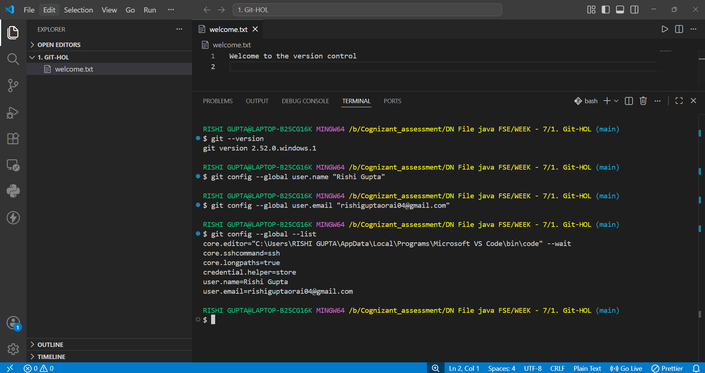

Step 2: Initialize Repository
Initialized Git repository and checked repository status.
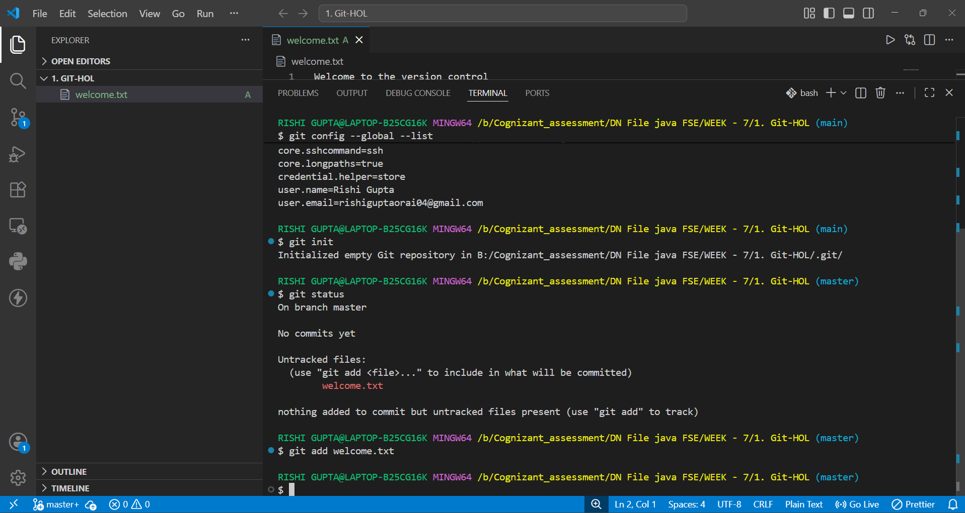

Step 3: Stage File
Added welcome.txt to the staging area using git add.
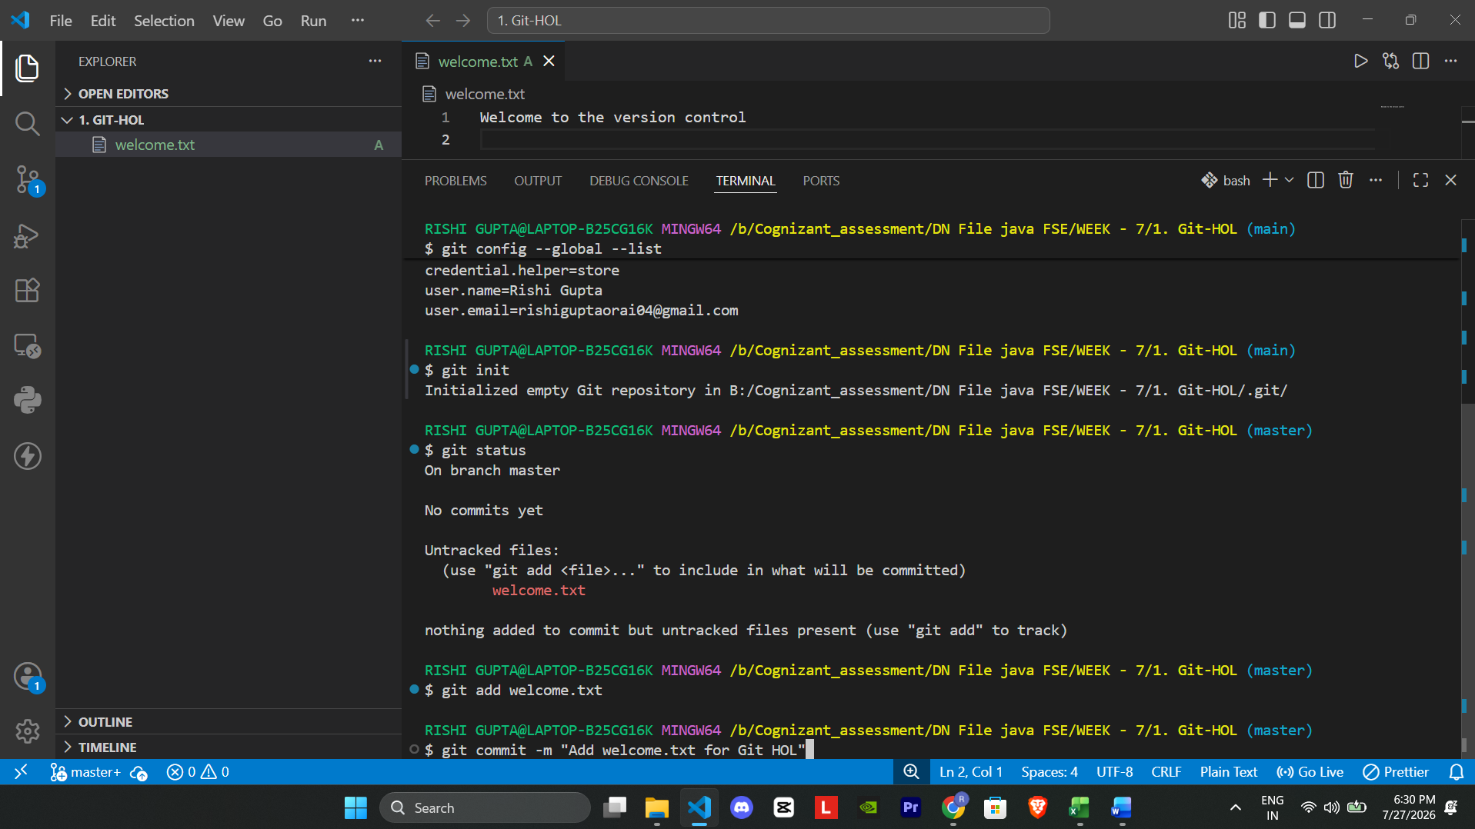

Conclusion
The Git environment was configured successfully. The repository was initialized, welcome.txt was created and staged successfully. Subsequent steps such as commit and push will complete the exercise.

